THE UNIVERSITY OF MANCHESTER, DEPT OF EARTH AND ENVIRONMENTAL SCIENCES

EART26201 PRINCIPLES OF GEOCHEMISTRY

LABORATORY COURSE HANDBOOK

September 2024

INTRODUCTION

The handbook is designed for the laboratory element of module EART26201(Principles of Geochemistry) - it outlines the aims of this laboratory and provides necessary information on health & safety, use of equipment and report writing. PLEASE READ THIS HANDBOOK CAREFULLY AND IN GOOD TIME BEFORE COMMENCING WORK.

AIMS OF LABORATORY COURSE
The aims of this laboratory course are to:

- enable you to gain experience of real chemical systems of relevance to important Earth systems
- enable you to reinforce learning of physical chemical principles with concrete practical examples
- introduce you to practical laboratory skills and working in a regulated practical environment
- develop your skill in making accurate and relevant observations
- develop your skill in recording your aims, methods, observations and interpretations
- enable you to gain an appreciation of natural variability occurring in experimental and analytical work.

GENERAL INFORMATION

The practical component of the EART26201 (Principles of Geochemistry) course unit will comprise of five 2-hour sessions. The laboratory class supervisors will be Dr Greg Holland for lab writeup and Jordan Gaskell for the practical experiments assisted by demonstrators in the lab 1.18. Check timetable for details.
During each laboratory class we ask you to:

- comply with the Health and Safety rules and guidelines

- ask for advice from your demonstrator or laboratory supervisors when you are in difficulty or doubt about how to execute or interpret any work: their job is to answer your questions or indicate how an answer might be found.
- record all pertinent information in an A4 laboratory book.

After each laboratory class we ask you to:
- complete any required written assignment. At the end of the laboratory class we ask you to: ensure that all glassware/bottles that you have been issued with are clean
- return all items issued to you clean and undamaged

[You may not be permitted into the laboratory class without a 100% mark in the Health and Safety Test and submittal of the signed Health and Safety Declaration]
Laboratory Records if required, complete immediately after practical session

Post-laboratory Exercises if required, complete in next classroom session

We hope that you enjoy this part of the course. Please read this entire handbook to maximise the benefit you gain and to familiarise yourselves with Health and Safety Rules and Guidelines designed to enhance your safety.
We strongly recommend that you prepare well for each practical and organise your laboratory time thoughtfully.
Most importantly, don't hesitate to ask if you need to know something - your laboratory class supervisors and demonstrators are there to help you.

HEALTH AND SAFETY: GENERAL

DEPARTMENTAL POLICY

The Earth and Environmental Sciences, Health and Safety document states "It is the aim of the School to comply with the University's general health and safety policy statement (available on the Health & Safety Services Webpages). To provide and maintain safe and healthy working conditions, equipment and systems of work for all staff and students; and to provide such information, training and supervision necessary for this purpose”
https://www.staffnet.manchester.ac.uk/ees/healthandsafety/ In pursuance of this policy it is the School's intention:
- to comply with the requirements of all relevant (Government and University) legislation and codes of practice;
- to provide systems of work that eliminate, as far as is reasonably practicable, hazards to safety and health;
- to promote systems of work that eliminate, as far as is reasonably practicable, hazards to safety and health;
- to provide such information, instruction, training and supervision as is necessary to ensure the health and safety of staff and students;
- to encourage staff to set high standards of safety by personal example so that students leaving the Department take with them an attitude of mind that accepts good safety practice as normal.

Reporting of Accidents to Students and Visitors
RIDDOR 1995 requires injuries to non-employees who require hospital treatment to be reported, no matter how minor (sprained ankles, cut fingers etc.). The injury must have arisen out of, or in connection with, work activities. All home or term address details need to be included for the injured person. All reports must be made immediately to Health and Safety Services.

EMERGENCY PROCEDURES
FIRE
The EES Health & Safety document further states that you should:

Familiarise yourself with the main escape route and with any alternative routes you may need to use if the main escape route becomes impassable.
In the event of fire turn off any gas or electrical appliances and provided the fire is only small, and provided you will not put yourself at risk, try to put it out with a hand- operated black carbon dioxide fire extinguisher. Do not, however, use more than two

separate hand extinguishers on any fire. If the fire still burns after having used the second hand appliance, sound the fire alarm and leave immediately.

ADVISORY NOTES FOR WILLIAMSON ROOM 1.18 (Person Responsible: Mr Jordan Gaskell)
For the 2023 session, laboratory classes will be held in Williamson Building, Room 1.18. (The corridor on your right as you enter the building by the Oxford Road entrance.)
If you have any queries or concerns arising from these notes contact the person responsible or the School Safety Adviser.
- All users of the facilities in this room must receive training from appropriate staff before beginning work.
- At the start of a class, the person in charge will explain the main risks in the laboratory of that day. However, you must have read the COSHH in this document before you have started your experiments.
- No smoking, and no food or drink to be taken into the laboratory.
- The use of radios, phones and/or personal stereos is not permitted.
- Emergency procedures to be followed in the event of an accident are posted in the laboratory and mentioned below.
- Wash hands after using any chemicals and keep your working area clean and tidy; a laboratory coat, safety glasses and gloves must be worn at all times.
- Beakers must be washed and left upside down to dry on blue roll after use. Dispose of consumables with care.
- All reagents and samples must be clearly labelled; with a personnel identifier in the case of work in progress.
- The laboratory must not be used as a store for bulk samples.
- The observation of simple precautions outlined below will minimise the risk of accidents.
- Work with care and attention at all times. Be aware of all potential hazards and risks, especially the large quantities of glassware in constant use.
- Be responsible for your own safety and the safety of others. Develop a comprehensive awareness of health and safety issues.
- Whenever appropriate use the quality assurance procedures manual, together with manufacturer's instructions, when using experimental rigs, apparatus and equipment.
- If in doubt, ASK.
- All breakages and borrowing must be documented in the appropriate log book.
- There are three principal types of potential hazard: chemicals, instruments / apparatus and fire.

- Chemicals
  - The Chemistry Laboratory (Room 1.18) is equipped with the facilities for the use of concentrated acids but they must remain within the fume hoods or secure storage areas.
  - Organic solvents main risks are from the flammability and inhalation of their vapours. ALL work involving these materials must be carried out in a well-ventilated area, there must be no naked flames or exposed electrical equipment.
  - Naked flames are not to be used in the open laboratory if organic solvents are in use.

Emergency procedures
Build-up of vapour and noxious gases
Remove personnel and ventilate the area.

Fire
Ensure you are familiar with the Building Fire Action procedures on discovering a fire and on hearing the alarm, both of which are shown on the Fire Action Notices on corridors and in this School Health and Safety Policy Document (see: Emergency Procedures section).
If possible, turn off any gas/electrical appliances and extinguish flames by using the appropriate extinguishers.
Ensure you are familiar with the types of extinguishers within the vicinity and their particular use (see: “Fighting the Fire” in the Emergency Procedures section of this Safety Policy Document. A fire extinguisher practical course can be arranged with the School Safety Adviser).
If this fails to stop the fire immediately remove all personnel from the room, close the doors behind you and follow the Building Evacuation Procedure.
Other Chemicals
All chemicals should be used with care. Some of these in regular use in the laboratory are highly toxic if ingested, inhaled or absorbed though the skin; such materials carry a warning on the container but can be used with safety if high standards of laboratory and personal cleanliness are maintained.

Emergency procedures:
Inhalation: move person into fresh air. If not breathing, give artificial respiration. Consult a physician.

Skin contact: Take off contaminated clothing and shoes immediately. Wash off with soap and plenty of water. Consult a physician.

Eye contact: Rinse thoroughly with plenty of water/eye wash for at least 15 minutes and consult a physician.

Swallowed: Do NOT induce vomiting. Never give anything by mouth to an unconscious person. Rinse mouth with water. Consult a physician.

Spillage on bench or floor: It is usually safe to sweep or mop up small spillages after neutralisation if necessary. Consult person in charge of the laboratory.

Notify COSHH safety advisor (Dr Abby Ragazzon-Smith) and report via the accident report form on the dept. H&S web site of any accidents, near misses and dangerous occurrences.

Further guidance specific to the experiments you will be undertaking in the WRC Laboratory
Chemical laboratories, including undergraduate teaching laboratories, unavoidably contain many potential hazards. To minimise accidents and injury in the chemistry laboratory, WE INSIST that you:
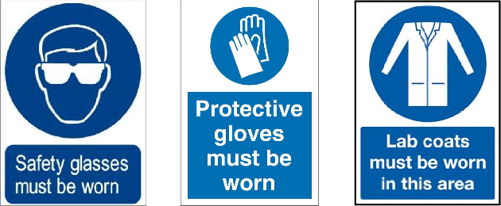

- Wear safety glasses or googles (meeting EN 1662001 ) at all times.
- Wear at all times a laboratory coat, which is fastened and sleeves are rolled down.
- Don’t have exposed limbs
- Nitrile protective gloves are worn at all times.
- Confine long hair and loose clothing.
- No personal electronic items. e.g. phones and laptops.
- Use fully enclosed shoes. No open front or back and no open weave type materials.
- Do not eat, chew gum, drink, smoke or apply cosmetics.
- Do not start work until you know the safety rules and procedures applicable to your work - ASK IF YOU DO NOT KNOW.

- Keep work areas dry, clean and tidy - you or others could be burned or exposed to hazardous substances if you do not clean up spillages immediately.
- Minimise exposure to all chemicals. This means avoid inhalation of gases and fine powder and avoid skin contact with any chemicals.
- Wash your hands well with water and detergent before leaving the laboratory.
- Think, act and encourage safe, considerate and responsible behaviour - be prepared and don't rush any operations. USE YOUR COMMON SENSE.
- Report any accident immediately to a laboratory class supervisor.
- DO NOT work in the laboratory outside the stated teaching hours. Working in a laboratory either alone or without adequate supervision is considered to be hazardous and is strictly forbidden by the Department.
- Only carry out the experiments in this manual according to procedures laid out herein. YOU WILL NOT conduct any other experiments or procedures without authorisation from the laboratory class supervisors.
- Do not pipette by mouth; always use a bulb-type pipette filler. If you do not have one, ask to borrow one and be careful to return it at the end of the lab class
In addition to these general rules there are a number of further rules and guidelines applicable to particular chemicals and apparatus. These include:
- When mixing the contents of a volumetric flask by shaking make sure that you hold both the base of the flask and the stopper at the top.
Do not hold filled volumetric flasks by the neck as the neck may not be strong enough to support the weight of the flask and the included solution.
Improper handling of volumetric flasks may result in BROKEN FLASKS, SEVERE CUTS and UNCONTROLLED RELEASE OF POTENTIALLY HAZARDOUS LIQUIDS.
- When pouring liquids, always make sure that you:
  - have the required reagent. CHECK THE LABEL!
  - be sure you can securely control the reagent bottle(s) if they are heavy
  - place the mouth of the flask/bottle as close as possible to that of the reagent bottle when pouring liquid
  - do not pour from a wide-mouthed bottle into a narrow-mouthed bottle unless you use a suitable funnel
- NEVER add water to a concentrated reagent- this may cause local heating and density contrasts that may cause the solution to splash or spit back on to you. Always perform a dilution of a reagent by adding reagent slowly to water.
- NEVER remove any chemical substance from the laboratory
- Use an adequately functioning FUME HOOD when required.

Further advice will be given by laboratory supervisors concerning COSHH and disposal of chemicals but for the reagents that you will be using the main hazards are listed on the COSHH form – see over page. Please read them careful and take careful

note of each so you know how to minimise the risk of exposure. COSHH is the Control of Substances Hazardous to Health Regulations 2002. Carrying out a COSHH risk assessment is required by law in order to minimise the risks of exposure or injury by working with hazardous substances.
ANY breach of these safety rules may endanger the safety of yourself and others and may result in you being excluded without compensation from the EART26201 laboratory course.

Hazards and their meanings Flammable 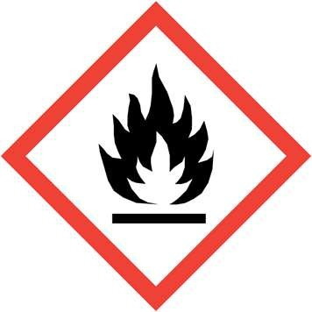
A substance or mixtures, which easily catches fire, pyrophoric and chemicals, which in contact with water emit flammable gases

Oxidizing 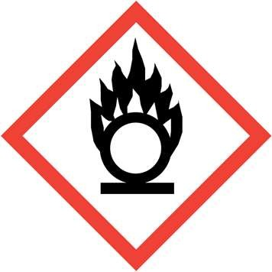
A substance that has the ability to oxidize other substances and cause them to catch fire.
Explosive 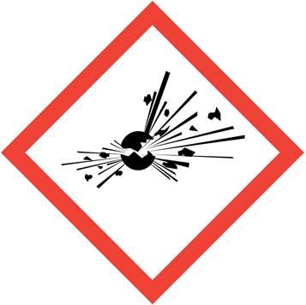
A reactive substance that contains a great amount of potential energy that can produce an explosion.

Toxic

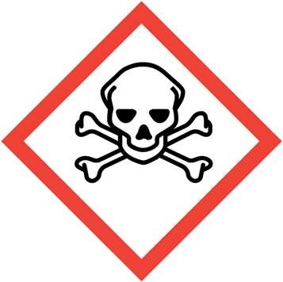
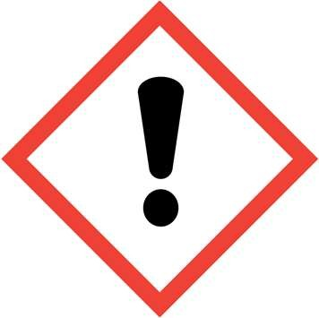
A substance, which on contact with skin, swallowed or inhaled may cause lethality to the entire body, lethality to specific organs, major/minor damage, or cause cancer.

Harmful
A substance, which has the potential to cause harm to life or health. Such as irritation of the eys and skin. Skin sensitization and specific target organ toxicity following single exposure
Health hazard 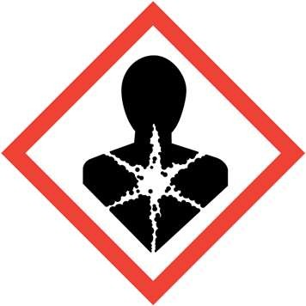
A substance which can have long term harm to health and life such as, respiratory sensaization, reproductive toxicity, mutagenicity issues and carcinogenicity.
Environmental hazard 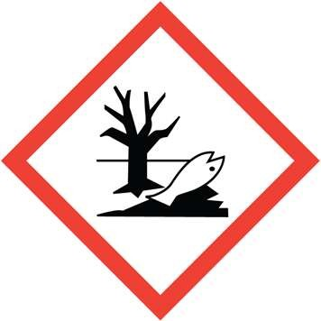
A substance which is ether harmful or toxic to the enviroment with long lasting effects.
Corrosive 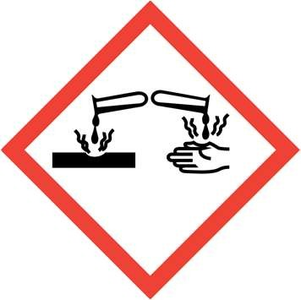
A substance which cources serious eye damage and corrosion to skin and metals.

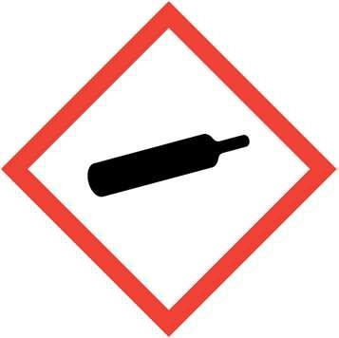
Compressed gases

- A substance which is stored as ether a compressed gases, liquefied gases, or
dissolved gases.

Danger!
The science labs can contain the following types of materials.

Teratogenic
A substance that may cause birth defects via a toxic effect on an embryo or foetus

Mutagenic
A Substance, which changes genetic material

Carcinogenic
A substance, which is directly involved in causing cancer

If you are pregnant, think you regnant, trying to get pregnant* or breast feeding / expressing please contact your Academic Tutor about the situation and Risk Assessment.
*Some substances can also affect sperm producers.

(1) In case of Emergency: Contact ether Dr Greg Holland 01612753810, Dr Abby Ragazzon-Smith 0161 2750394 |  |  |  |  | (2) Fire  Fighting Water (Red)  medium
The following services are being used: | Elec trici ty  ☒ | Wat er  ☐ | Gases: (specify)  Click here to enter text. |  | Other:  Click here to enter text.
Action in Evacuate lab and lead students to  case of the nearest exit making certain  Fire: that all students have left the lab. |  |  |  |  | Spillage or Use blue paper towel  release to swab up and then  measures: place in a fume hood  for later disposal once the students have finished in the lab.
First aid Inhalation: move person into fresh air. If not breathing, give artificial
requireme respiration. Consult a physician.
nts: Skin contact: Take off contaminated clothing and shoes immediately.
Wash off with soap and plenty of water. Consult a physician.
Eye contact: Rinse thoroughly with plenty of water/eye wash for at least 15 minutes and consult a physician.
Swallowed: Do NOT induce vomiting. Never give anything by mouth to an unconscious person. Rinse mouth with water. Consult a physician.
Notify COSHH safety advisor (Dr Abby Ragazzon-Smith) and report via the accident report form on the dept. H&S web site of any accidents, near misses and dangerous occurrences.
This is a chemical risk assessment only and other assessments may be required. All
associated assessment forms must be displayed close to the procedure.
(3) Risk AHRS-22-  Assessme GeochemP1-5  nt Number/  Code: |  |  |  | (4) Name and Dr Greg  status of Holland, Dr  researcher e.g. Abby  Phd.. Ragazzon-  Smith |  |  | (5) See  Emergen sect  cy ion  contact 1  details:
(6) 20/04/20  Asses 20  smen  t Date: | (7) 20/0  Revi 4/20  ew/E 22  xpiry Date: |  |  | (8) B08c  Buildin William g and son office Building  Numbe  r: |  | (9) 1.18, 1.18b,  Lab 1.22.  Num g12-  ber: g16. | (10) 2nd People year Affected UG  : stud  ents  and supe rviso ry  staff
(11) Student use of reagents during geochemistry practical’s
Title
of proce dure:

(12) Details of procedure and where applicable reaction scheme  (Including starting materials, products/by-products and pressure): |  |  |  |  |  |  | (14) Associated Assessments and  Ref
For the preparation and running of the teaching of the Earth and Environmental Sciences Geochemistry laboratory based practical. See rest of hand book for the experimental methodology. |  |  |  |  |  |  | General risk assessme nt for |  | ☐
 |  |  |  |  |  |  | experime
 |  |  |  |  |  |  | nt
 |  |  |  |  |  |  | Equip/Ex
 |  |  |  |  |  |  | p  overnight |  | ☐
 |  |  |  |  |  |  | running
 |  |  |  |  |  |  | General
 |  |  |  |  |  |  | lab |  | ☐
 |  |  |  |  |  |  | activities
 |  |  |  |  |  |  | Ionizing |  | ☐
 |  |  |  |  |  |  | radiation
 |  |  |  |  |  |  | Non-
 |  |  |  |  |  |  | Ionizing |  | ☐
 |  |  |  |  |  |  | radiation
 |  |  |  |  |  |  | Laser |  | ☐
 |  |  |  |  |  |  | Safety
 |  |  |  |  |  |  | Biological
 |  |  |  |  |  |  | /Bio- |  | ☐
 |  |  |  |  |  |  | COSHH
 |  |  |  |  |  |  | Radiologi |  | ☐
 |  |  |  |  |  |  | cal
(13) Duration, Frequency and Temperature Range:  Click here to enter text.  Four times a year for two hours each. |  |  |  |  |  |  | RA/P&M Sheets/SOP/Othe r (include ref): Click here to  enter text.
(15)  Substanc es used and produced | (16)  Quant ity used and handl ed | (17)  Durati on of poten tial expos ure | (18)  Hazar d Symb ols | (19) Physical and health hazard  statements Highlight primary hazard | (20)  Workpl ace Exposu re Limits | (21) Control Measures |  | (2  2)  Di sp os al Ro ut e |  | (23)  Extr em ely or Hig hly Fla mm  abl
 | (16)  Quant ity used and handl ed |  |  |  |  |  |  |  |  | e?
Click Her e
Experiment 1
1.  0.0025M  hydrochl oric acid  CAS: | 100ml | Up to 2  hours | 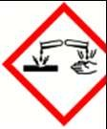  Click | H290 May be corrosive to metals | Click here to | Eye/face protection: Tightly fitting safety glasses tested to EN 166(EU).Skin protection:  Handle with gloves. |  | Down sink with lots of  water. |  |  | ☐

7647-01-  0 |  |  | Her e Click Her e |  | enter text. | Gloves to standard EN  374. Material: Nitrile rubber. Minimum layer thickness: 0.11 mm. Always inspect gloves before use and remove using correct technique to avoid contact with glove surface. Follow good lab practice and wash hands after handling and before breaks. Body Protection: Chemical resistant lab coat to be worn at all times.
2.  0.0025M  nitric acid | 100ml | Up to 2  hours | 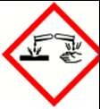 | H290 May be corrosive to metals | Click here | Eye/face protection:  Tightly fitting safety  glasses tested to EN | Down sink  with
CAS: 7697-37-  2 |  |  | Click Her  e |  | to  enter text. | 166(EU).Skin protection:  Handle with gloves. Gloves to standard EN  374. Material: Nitrile | lots of water.
 |  |  | Click Her |  |  | rubber. Minimum layer  thickness: 0.11 mm.  Always inspect gloves
 |  |  | e  Click Her |  |  | before use and remove using correct technique to avoid contact with  glove surface. Follow |  | ☐
 |  |  | e |  |  | good lab practice and  wash hands after
 |  |  |  |  |  | handling and before
 |  |  |  |  |  | breaks. Body Protection:
 |  |  |  |  |  | Chemical resistant lab
 |  |  |  |  |  | coat to be worn at all
 |  |  |  |  |  | times.
3.  0.0025M  acetic acid CAS: 64-19-7 | 100ml | Up to 2  hours | Click Her e  Click | This item is not a hazardous substance | Click here to  enter | Eye/face protection: Tightly fitting safety glasses tested to EN 166(EU).Skin protection: Handle with gloves.  Gloves to standard EN  374. Material: Nitrile rubber. Minimum layer thickness: 0.11 mm. Always inspect gloves before use and remove using correct technique to avoid contact with glove surface. Follow good lab practice and wash hands after handling and before breaks. Body Protection: Chemical resistant lab coat to be worn at all times. | Down sink with lots of water.
 |  |  | Her |  | text.
 |  |  | e
 |  |  | Click
 |  |  | Her  e |  |  |  |  | ☐
 |  |  | Click
 |  |  | Her
 |  |  | e
4. | 100ml | Up to | 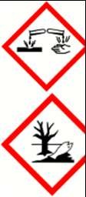  Click Her | H315 Causes skin | Click here to enter text. | Eye/face protection: | Down
0.0025M |  | 2 |  | irritation. | Click here to enter text. | Tightly fitting safety | sink
ammoniu |  | hours |  | H318 Causes serious | Click here to enter text. | glasses tested to EN | with
m |  |  |  | eye damage. | Click here to enter text. | 166(EU).Skin protection: | lots of
hydroxid  e CAS: |  |  |  | H412 Harmful to  aquatic life with long | Click here to enter text. | Handle with gloves.  Gloves to standard EN | water. | ☐
1336-21- |  |  |  | lasting effects. | Click here to enter text. | 374. Material: Nitrile
6 |  |  |  |  | Click here to enter text. | rubber. Minimum layer
 |  |  |  |  | Click here to enter text. | thickness: 0.11 mm.
 |  |  |  |  | Click here to enter text. | Always inspect gloves

 |  |  | e Click Her e |  |  | before use and remove using correct technique to avoid contact with glove surface. Follow good lab practice and wash hands after handling and before breaks. Body Protection: Chemical resistant lab coat to be worn at all  times.
5.  0.0025M  ammoniu | 100ml | Up to 2  hours | Click Her | Not a hazardous substance | Click here | Eye/face protection:  Tightly fitting safety  glasses tested to EN | Down sink  with
m |  |  | e |  | to | 166(EU).Skin protection: | lots of
acetate  CAS: 631-  61-8 |  |  | Click Her |  | enter text. | Handle with gloves.  Gloves to standard EN  374. Material: Nitrile | water.
 |  |  | e |  |  | rubber. Minimum layer
 |  |  | Click Her |  |  | thickness: 0.11 mm.  Always inspect gloves before use and remove |  | ☐
 |  |  | e  Click |  |  | using correct technique  to avoid contact with  glove surface. Follow
 |  |  | Her |  |  | good lab practice and
 |  |  | e |  |  | wash hands after  handling and before
 |  |  |  |  |  | breaks. Body Protection:
 |  |  |  |  |  | Chemical resistant lab
 |  |  |  |  |  | coat to be worn at all
 |  |  |  |  |  | times.
6.Barium hydroxid e solution CAS: 17194-  00-2 | 100ml | Up to 2  hours | 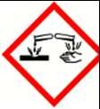  Click Here  Click  Her | H315 Causes skin irritation.  H318 Causes serious eye damage | TWA  0.5mg/ m3 | Eye/face protection: Tightly fitting safety glasses tested to EN 166(EU).Skin protection: Handle with gloves.  Gloves to standard EN  374. Material: Nitrile rubber. Minimum layer thickness: 0.11 mm. Always inspect gloves before use and remove using correct technique to avoid contact with glove surface. Follow good lab practice and wash hands after handling and before breaks. Body Protection: Chemical resistant lab coat to be worn at all times. | Lead and silver solutio ns must be transf erred to contai ner and remov al arrang ed with memb er of staff.
 |  |  | e
 |  |  | Click
 |  |  | Her |  |  |  |  | ☐
 |  |  | e
7. 0.25M  sulphuric acid CAS: 7664-93-  9 | 100ml | Up to 2  hours | 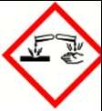  Click Her | H290 May be corrosive to metals | Click here to enter | Eye/face protection: Tightly fitting safety glasses tested to EN 166(EU).Skin protection: Handle with gloves.  Gloves to standard EN  374. Material: Nitrile rubber. Minimum layer thickness: 0.11 mm. Always inspect gloves before use and remove using correct technique to avoid contact with glove surface. Follow good lab practice and wash hands after  handling and before | Down sink with lots of water.
 |  |  | e |  | text.
 |  |  | Click  Her |  |  |  |  | ☐
 |  |  | e
 |  |  | Click
 |  |  | Her
 |  |  | e

breaks. Body Protection: Chemical resistant lab coat to be worn at all
times.
Barium | 100ml | Up to |  | Not a hazardous substance or mixture according to Regulation (EC) No 1272/2008 |  | Eye/face protection: | Collect
sulphate |  | 2 |  |  |  | Tightly fitting safety | as
CAS: |  | hours |  |  |  | glasses tested to EN | bulk
7727437 |  |  |  |  |  | 166(EU).Skin protection: | liquid
 |  |  |  |  |  | Handle with gloves. | waste
 |  |  |  |  |  | Gloves to standard EN | and
 |  |  |  |  |  | 374. Material: Nitrile | filter
 |  |  |  |  |  | rubber. Minimum layer | to
 |  |  |  |  |  | thickness: 0.11 mm. | obtain
 |  |  |  |  |  | Always inspect gloves | solid
 |  |  |  |  |  | before use and remove | for
 |  |  |  |  |  | using correct technique | chemi
 |  |  |  |  |  | to avoid contact with | cal
 |  |  |  |  |  | glove surface. Follow | dispos
 |  |  |  |  |  | good lab practice and | al
 |  |  |  |  |  | wash hands after
 |  |  |  |  |  | handling and before
 |  |  |  |  |  | breaks. Body Protection:
 |  |  |  |  |  | Chemical resistant lab
 |  |  |  |  |  | coat to be worn at all
 |  |  |  |  |  | times.
 |  |  |  |  |  | Respiratory protection:
 |  |  |  |  |  | Fume hood.
Experiment 2 + 3
Buffer | 100ml | Up to |  | Not a hazardous |  | Eye/face protection: | Down
solutions |  | 2 |  | substance |  | Tightly fitting safety | sink
(pH4) |  | hours |  |  |  | glasses tested to EN | with
 |  |  |  |  |  | 166(EU).Skin protection: | lots of
 |  |  |  |  |  | Handle with gloves. | water.
 |  |  |  |  |  | Gloves to standard EN
 |  |  |  |  |  | 374. Material: Nitrile
 |  |  |  |  |  | rubber. Minimum layer
 |  |  |  |  |  | thickness: 0.11 mm.
 |  |  |  |  |  | Always inspect gloves
 |  |  |  |  |  | before use and remove
 |  |  |  |  |  | using correct technique
 |  |  |  |  |  | to avoid contact with
 |  |  |  |  |  | glove surface. Follow
 |  |  |  |  |  | good lab practice and
 |  |  |  |  |  | wash hands after
 |  |  |  |  |  | handling and before
 |  |  |  |  |  | breaks. Body Protection:
 |  |  |  |  |  | Chemical resistant lab
 |  |  |  |  |  | coat to be worn at all
 |  |  |  |  |  | times.
Buffer | 100ml | Up to |  | Not a hazardous |  | Eye/face protection: | Down
solutions |  | 2 |  | substance |  | Tightly fitting safety | sink
(pH7) |  | hours |  |  |  | glasses tested to EN | with
 |  |  |  |  |  | 166(EU).Skin protection: | lots of
 |  |  |  |  |  | Handle with gloves. | water.
 |  |  |  |  |  | Gloves to standard EN
 |  |  |  |  |  | 374. Material: Nitrile
 |  |  |  |  |  | rubber. Minimum layer
 |  |  |  |  |  | thickness: 0.11 mm.
 |  |  |  |  |  | Always inspect gloves
 |  |  |  |  |  | before use and remove
 |  |  |  |  |  | using correct technique
 |  |  |  |  |  | to avoid contact with
 |  |  |  |  |  | glove surface. Follow
 |  |  |  |  |  | good lab practice and
 |  |  |  |  |  | wash hands after
 |  |  |  |  |  | handling and before
 |  |  |  |  |  | breaks. Body Protection:
 |  |  |  |  |  | Chemical resistant lab

 |  |  |  |  |  | coat to be worn at all times.
0.1M  hydrochl oric acid CAS: 7647-01-  0 | 100ml | Up to 2  hours | 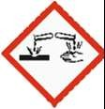 | H290 May be corrosive to metals |  | Eye/face protection: Tightly fitting safety glasses tested to EN 166(EU).Skin protection: Handle with gloves.  Gloves to standard EN  374. Material: Nitrile rubber. Minimum layer thickness: 0.11 mm. Always inspect gloves before use and remove using correct technique to avoid contact with glove surface. Follow good lab practice and wash hands after handling and before breaks. Body Protection: Chemical resistant lab coat to be worn at all  times. | Down sink with lots of water.
0.01M  sodium hydroxid e  CAS: 1310-73-  2 | 100ml | Up to 2  hours |  | Not a hazardous substance |  | Eye/face protection: Tightly fitting safety glasses tested to EN 166(EU).Skin protection: Handle with gloves.  Gloves to standard EN  374. Material: Nitrile rubber. Minimum layer thickness: 0.11 mm. Always inspect gloves before use and remove using correct technique to avoid contact with glove surface. Follow good lab practice and wash hands after handling and before breaks. Body Protection: Chemical resistant lab coat to be worn at all  times. | Down sink with lots of water.
1%  screened methyl orange indicator solution. (contains methanol  ) | A few drops from 250ml bottle | Up to 2  hours | 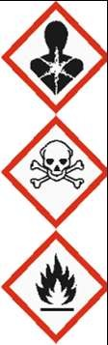 | H225 Highly flammable liquid and vapour.  H301 + H311 + H331  Toxic if swallowed, in contact with skin or if inhaled.  H370 Causes damage to organs. | TWA  200pp m | Eye/face protection: Tightly fitting safety glasses tested to EN 166(EU).Skin protection: Handle with gloves.  Gloves to standard EN  374. Material: Nitrile rubber. Minimum layer thickness: 0.11 mm. Always inspect gloves before use and remove using correct technique to avoid contact with glove surface. Follow good lab practice and wash hands after handling and before breaks. Body Protection: Chemical resistant lab coat to be worn at all  times.

0.5 wt% phenolph thalein indicator solution | A few drops from a 250ml bottle | Up to 2  hours | 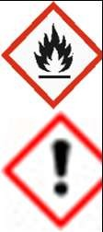 | H226 Flammable liquid and vapour. H319 Causes serious eye irritation. | 1000pp m TWA | Eye/face protection: Tightly fitting safety glasses tested to EN 166(EU).Skin protection: Handle with gloves.  Gloves to standard EN  374. Material: Nitrile rubber. Minimum layer thickness: 0.11 mm. Always inspect gloves before use and remove using correct technique to avoid contact with glove surface. Follow good lab practice and wash hands after handling and before breaks. Body Protection: Chemical resistant lab coat to be worn at all  times.
Sodium chloride  CAS: 7440-23-  5 | 100ml | Up to 2  hours |  | Not a hazardous substance |  | Eye/face protection: Tightly fitting safety glasses tested to EN 166(EU).Skin protection: Handle with gloves.  Gloves to standard EN  374. Material: Nitrile rubber. Minimum layer thickness: 0.11 mm. Always inspect gloves before use and remove using correct technique to avoid contact with glove surface. Follow good lab practice and wash hands after handling and before breaks. Body Protection: Chemical resistant lab coat to be worn at all  times. | Down sink with lots of water.
0.1M  sodium carbonat e  CAS: 497-  19-8 | 100ml | Up to 2  hours |  | Not a hazardous substance |  | Eye/face protection: Tightly fitting safety glasses tested to EN 166(EU).Skin protection: Handle with gloves.  Gloves to standard EN  374. Material: Nitrile rubber. Minimum layer thickness: 0.11 mm. Always inspect gloves before use and remove using correct technique to avoid contact with glove surface. Follow good lab practice and wash hands after handling and before breaks. Body Protection: Chemical resistant lab coat to be worn at all  times. | Down sink with lots of water.
0.01M  sodium bicarbon ate  CAS: 144-  55-8 | 100ml |  |  | Not a hazardous substance |  | Eye/face protection: Tightly fitting safety glasses tested to EN 166(EU).Skin protection: Handle with gloves.  Gloves to standard EN  374. Material: Nitrile  rubber. Minimum layer | Down sink with lots of water.

thickness: 0.11 mm. Always inspect gloves before use and remove using correct technique to avoid contact with glove surface. Follow good lab practice and wash hands after handling and before breaks. Body Protection: Chemical resistant lab coat to be worn at all
times.
Preparation Materials (not handled by undergraduate students)
Click here to enter text.
Conc Ammoniu m Hydroxid e.  CAS:1336  -21-6 | 100ml form 2500  ml stock bottle | Up to 2  hours | 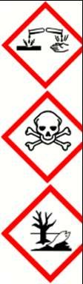 | H302 Harmful if swallowed.  H314 Causes severe skin burns and eye damage.  H335 May cause respiratory irritation. H400 Very toxic to aquatic life. |  | Eye/face protection: Tightly fitting safety goggles, Or Tightly fitting safety glasses and Face shield (8-inch minimum) tested to EN 166(EU).  Skin protection: Handle with gloves. Gloves to standard EN 374.  Material: Nitrile rubber. Chem Neo Nitrile 300. Always inspect gloves before use and remove using correct technique to avoid contact with glove surface. Follow good lab practice and wash hands after handling and before breaks. Body Protection: Chemical resistant lab coat to be worn at all times. Respiratory  protection: Fume hood.
Conc Hydrochl oric acid. CAS: 7647-01-  0 | 100ml form 2500  ml stock bottle | Up to 2  hours | 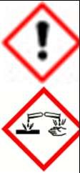 | H290 May be corrosive to metals.  H314 Causes severe skin burns and eye damage.  H335 May cause respiratory irritation. | 10 ppm STEL | Eye/face protection: Tightly fitting safety goggles, Or Tightly fitting safety glasses and Face shield (8-inch minimum) tested to EN 166(EU).  Skin protection: Handle with gloves. Gloves to standard EN 374.  Material: Nitrile rubber. Chem Neo Nitrile 300. Always inspect gloves before use and remove using correct technique to avoid contact with glove surface. Follow good lab practice and wash hands after handling and before breaks. Body Protection: Chemical resistant lab coat to be worn at all times. Respiratory protection: Fume hood.

Conc Nitric acid. CAS: 7697-37-  2 | 100ml form 2500  ml stock bottle | Up to 2  hours | 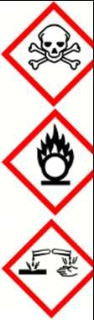 | H272 May intensify fire; oxidizer.  H290 May be corrosive to metals.  H314 Causes severe skin burns and eye damage.  H331 Toxic if inhaled. Precautionary statement(s)  P210 Keep away from heat, hot surfaces, sparks, open flames and other  ignition sources. No smoking. | 1 ppm STEL | Eye/face protection: Tightly fitting safety goggles, Or Tightly fitting safety glasses and Face shield (8-inch minimum) tested to EN 166(EU).  Skin protection: Handle with gloves. Gloves to standard EN 374.  Material: Nitrile rubber. Chem Neo Nitrile 300. Always inspect gloves before use and remove using correct technique to avoid contact with glove surface. Follow good lab practice and wash hands after handling and before breaks. Body Protection: Chemical resistant lab coat to be worn at all times. Respiratory protection: Fume hood.
Acetic Acid (Glacial) CAS: 64-  19-7 | 100ml form 2500  ml stock bottle | Up to 2  hours |  | H226 Flammable liquid and vapour.  H290 May be corrosive to metals.  H314 Causes severe skin burns and eye damage. |  | Eye/face protection: Tightly fitting safety goggles, Or Tightly fitting safety glasses and Face shield (8-inch minimum) tested to EN 166(EU).  Skin protection: Handle with gloves. Gloves to standard EN 374.  Material: Nitrile rubber. Chem Neo Nitrile 300. Always inspect gloves before use and remove using correct technique to avoid contact with glove surface. Follow good lab practice and wash hands after handling and before breaks. Body Protection: Chemical resistant lab coat to be worn at all times. Respiratory protection: Fume hood.
6.Barium hydroxid e CAS: 17194-  00-2 | 100ml | Up to 2  hours | 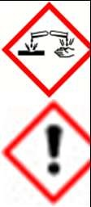  Click Her e Click Her e | H302  Harmful if swallowed. H314  Causes severe skin burns and eye damage. | TWA  0.5mg/ m3 | Eye/face protection: Tightly fitting safety glasses tested to EN 166(EU).Skin protection: Handle with gloves.  Gloves to standard EN  374. Material: Nitrile rubber. Minimum layer thickness: 0.11 mm. Always inspect gloves before use and remove using correct technique to avoid contact with glove surface. Follow good lab practice and wash hands after handling and before breaks. Body Protection: Chemical resistant lab coat to be worn at all  times.

Respiratory protection:
Fume hood.
(24) Operation is (mark as appropriate): Open ☒ Closed ☐Pressurised ☐ Pressure
relief system ☐ other ☐ Please specify here.
(25) Are you carrying out an activity/chemical reaction that is at risk of a thermal runaway or explosion? No
If yes, what additional controls are required? Click here to enter text.
(26) Will the activity involve handling or storage of pyrophoric or unstable substances such as peroxide? No
If yes, what additional controls are required? Click here to enter text.
(27) Will flammable vapours, solid particles, fibrous particles etc. capable of forming an explosive atmosphere be present? Yes
If yes, what additional controls are required? Keep away from spark, open flames and heat sources.
(28) Can less hazardous substances be used? No
(29) Procedure for checking effectiveness of control measures
Wipe down all surfaces with damp inert absorbent material i.e. blue roll between preparations of each chemical to prevent spread of hazardous substance. Ensure extraction is greater than 0.5m/s at a working sash height.
Carry out all work with corrosive liquids within a fume cupboard.
(30) If Carcinogens, mutagens or reproductive toxins (CMR), skin sensitisers, respiratory sensitisers, occupational asthmagens or nanoparticles are listed, is the fitness to work certificate for each individual  still valid? Choose an item. |  |  |  |  |  | (31) If any of the Substances above are highly flammable and extremely flammable, What control measures are in place? Click here to enter text.
(32) Is lone working permitted for this procedure? Choose an item.  If yes, what additional controls for lone working are required?  Click here to enter text. |  |  |  |  |  | (33) Is out of hours working permitted for this procedure? Choose an item.  If yes, what additional controls for out of hours working are required?  Click here to enter text.
(34) Additional control measures or relevant information. Click here to enter text.
Keep indicator solutions away from heat, hot surfaces, sparks, open flames and other ignition sources.
(35) Risk rating of the experiment: Low
Signatories
We have discussed this chemical risk assessment and understand the hazards and the associated control measures required. A copy of this form must be displayed close to the reaction.
- Signature of Assessor:  ………………………………………………  ………………………  - Signature of Approver: |  |  |  |  | Print Name:  …………………………………………………  ………………………………  Print Name: |  |  |  | Date:  ……………………………  ……………………………  …  Date:

……………………………………………… | ………………………………………………… | ……………………………
……………………… | ……………………………… | ……………………………
(38) Signature of Verifier: | Print Name: | …
……………………………………………… | Dr Abby Ragazzon-Smith | Date:
……………………… |  | ……………………………
(where necessary) |  | ……………………………  …

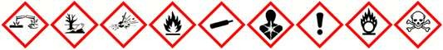

HEALTH AND SAFETY TEST

NAME:

DATE:

CLASS: EART26201 Geochemistry

(To be completed in your own time and returned to your laboratory supervisors BEFORE the commencement of the laboratory course)

- What three items of safety clothing must be worn as a minimum at all times when in the laboratory?

- You are unsure about whether a procedure is safe or not. What should you do?

- What should you do if a fire alarm rings ?

- What must you do in the event of any accident, however minor it may seem ?

- If you have long hair or loose clothing what should you ensure before commencing work in the laboratory ?

- What precautions should you take when dispensing chemicals from a bottle ?

- You have finished your practical work for the day and are plotting a graph in the laboratory. Do you need to wear a laboratory coat and safety spectacles ?

- You are running out of time to complete an experiment. What should you do?

- Is it acceptable to eat, drink, smoke or apply cosmetics in the laboratory, justify your answer?

- You have failed to complete the practical work during the allotted laboratory course hours. Should you attempt to complete the practical at another time when the laboratory supervisors are not present ?

- You should avoid skin and eye contact with all chemicals. But is this still true if you are washing up and know what the chemicals are and think that they are safe?

- You have spilt some acid on the bench or floor, what do you do?

- Why must you clean and tidy your bench at the end of the day ?

HEALTH AND SAFETY DECLARATION
To the student:

It is essential that you are aware of the basic health and safety policies relevant to your laboratory work. We ask that you read the "Health and Safety" section of this handbook and that you discuss this with your laboratory supervisors prior to the scheduled laboratory classes. We ask that you indicate your understanding and acceptance of the health and safety rules and guidelines outlined therein by returning a signed copy of this page to the School.
++++++++++++++++++++++++++++++++++++++++++++++++++++++++++++++++

To: The Head of School, School of Earth, Atmospheric and Environmental Sciences University of Manchester M13 9PL
I have read and fully understood the "Health and Safety" section of the University of Manchester, School of Earth, Atmospheric and Environmental Sciences, Laboratory Course Handbook for EART26201EART26201 dated October 2017.
I agree to comply with the safety rules and guidelines stated therein and understand that any failure to comply with these rules and guidelines may result in my exclusion without compensation from EART26201EART26201 laboratory classes.
I understand that I may be excluded without compensation from EART26201EART26201 laboratory classes should I not pass the required Health and Safety test prior to the commencement of the laboratory classes.
I understand and agree that I will be liable for the replacement cost of any glassware or other piece of equipment damaged as a result of my actions during EART26201EART26201 laboratory classes.
Signed:

Name (in BLOCK letters):

Date:

TO BE COMPLETED BY LABORATORY SUPERVISOR:

Result of Health and Safety Test: Mark:
Date:

Assessed By Signature:

PRE-LABORATORY PREPARATION
An organised professional will prepare in advance for work that he/she is going to undertake. This generally enables:
- potential problems to be identified
- the work to be carried out with less fuss and in a more relaxed and controlled manner with resultant greater efficiency of time and effort, better accuracy and improved safety.
This applies to your laboratory classes.

Indeed, you will find it difficult to complete all the tasks required in the space of each laboratory session unless you do some advance preparation.
Each week you should prepare for the forthcoming laboratory class by: reading the objectives, introduction and procedure for the experiment
- try and relate the procedure to the objectives to assess what degree of accuracy might be required for each step
- make a note of any step or steps in the procedure that you do not understand and, if appropriate, ask your demonstrator or supervisor for clarification prior to commencing the practical
- make a list of equipment and reagents that you will require so that you can check the availability of these at the beginning of the practical
- note what possible safety hazards you might meet during the experiment and what precautions you should take against these
- note which techniques you will be required to use and whether or not you know how to use them
- carry out any necessary background reading

WRITING LABORATORY RECORDS
An important objective of the laboratory course is to develop your skill in recording experimental work.
The body of scientific knowledge is based on detailed experimental evidence obtained by numerous workers in different places at different times.
The development of science as a whole or indeed of any particular academic or industrial research or non-research project generally requires evidence to be considered, checked, criticised or assessed in relation to other items of evidence.
In order for such appraisal to be carried out, experimental evidence must be COMMUNICATED or be available for communication.
Experimental evidence is normally written up in two forms:

- an original record or laboratory record
- a report
We outline below essential points regarding the writing of laboratory records:

The laboratory record should be an accurate record of actual procedures carried out, actual observations made as well as the details of any calculations made. It should be written as an original record at the time of doing the experiment. As such, mistakes, failures and accidents should all be recorded. It should, at all times, be a record of what actually happened, not what you intended, predicted or wanted to happen.
You should write your laboratory records as follows:

- The laboratory record should be written in a duplicate note book with numbered pages. You should:
  - write your name, course and year on the front cover
  - reserve the first two pages for an index
- The laboratory record should consist of the following sections:
  - Title of experiment and date carried out
  - Procedure followed (or reference to it together with any modifications to the procedure, if appropriate) [for EART26201: there is no need to reproduce what is in the laboratory handbook]
  - Results [for EART26201: a series of datasheets are given to you for each experiment. These are provided to offer a guide as to the critical information that you should be recording. Everyone is expected to record this information in their personal laboratory record, whilst we may ask for
a set of data sheets to be submitted by each group from time to time
  - Calculations/preliminary interpretations
  - Summary/conclusion

- You should write legibly and neatly. Remember to space the information out for ease of reading and to use tables and sketched graphs as appropriate.
- ALL experimental data should be recorded at the time they are obtained. Do not use scraps of paper or rely upon your memory.
- Do not scribble out, tippex over or rip out mistakes. If you make a recording error, draw a line through it and make the necessary revised entry.
- It is traditional to write the laboratory record in the 3rd person, past tense (since it is recording what has just happened). For example: "A black precipitate was observed".
- Avoid spilling water or chemicals on to your laboratory record.
- Bring your laboratory record to all laboratory classes.
- You will submit your laboratory notebook for marking in week 12 of the semester.

PRACTICAL LABORATORY TECHNIQUES

VOLUMETRIC GLASSWARE - GENERAL POINTS
Solutions of known compositions may be prepared accurately using volumetric apparatus - namely pipettes, burettes and volumetric flasks. These items are typical glassware, the volume of which has been accurately factory calibrated and marked. To use them accurately ALL these items:
- must be kept scrupulously clean
- must NEVER be heated (as the glass expands rapidly and is slow to regain its original dimensions)
- must be read and used correctly
On all three types of apparatus calibrated volumes are either etched or marked as a circle on the glass. For most aqueous solutions contained in glass pipettes, burettes and volumetric flasks, the top surface of the liquid is not flat but forms a curved surface, called a "meniscus". Typically this surface is highest adjacent to the glass surface or sides of the vessel and slightly lower in the middle of the vessel. When making a reading you must make sure that
- your eye is at the same level as the meniscus (in order to avoid problems due to parallax)
- the meniscus level is read at the curve's centre (i.e. the lowest point generally for a water meniscus in a glass vessel)
- In addition there are some points to be made specific to each type of apparatus:

PIPETTES
Pipettes are used for transferring accurately known volumes of liquid.

Pipettes are either calibrated for a particular volume or have calibrated graduations for several different volumes.

BURETTES
Burettes are designed to sequentially dispense accurate volumes of liquids, typically for titrations.
Burettes are similar in design to pipettes except that they have a stopcock at their base.

Simpler burettes such as you will generally be using are filled from the top using a funnel. It is a useful practice to clean out the burette with the solution you are about to dispense by allowing 5 ml or so of solution out to waste before starting a titration.
When dispensing liquid, the stopcock on the burette should be GENTLY and SLOWLY opened and closed by using ONE HAND ONLY placed behind the burette away from the operator. Burettes are fragile items so great care and finesse is required in their use.
The volume of solution dispensed by a burette is calculated by noting the calibration mark the solution meniscus reached before dispensing and subtracting this from the calibration mark the solution meniscus is level with after dispensing.
Thus, it is clearly impractical to fill a burette to higher than the "0.00 ml" calibration mark unless you wish to use the solution above this mark to initially rinse the burette out.

VOLUMETRIC FLASKS
Volumetric flasks are used for the accurate preparation of solutions.

These flasks generally have just one calibration mark on the neck of the vessel. When the meniscus of the solution is level with this mark, the volume of the solution is that imprinted on the flask at the stated temperature (usually 20°C).
As for pipettes and burettes, it is good practice to rinse a volumetric flask with the solvent before use.
If a volumetric flask is to be used to make up solution from solids and solvent, then the solids should be completely dissolved BEFORE the volume is made up to mark.
HEALTH AND SAFETY RULES

When mixing the contents of volumetric flask by shaking make sure that you hold both the flask base and the stopper at the top.
Do not hold filled volumetric flasks by the neck, as the neck may not be strong enough to support the weight of the flask and the included solution.
Improper handling of volumetric flasks may result in BROKEN FLASKS, SEVERE CUTS and UNCONTROLLED RELEASE OF POTENTIALLY HAZARDOUS LIQUIDS.
Pressure inside a flask may increase during shaking. It is therefore prudent to periodically release any such pressure build-up by slowly pulling the stopper out. If the stopper is stuck, NEVER forcefully pull it out as the flask neck may break and slice your fingers. Ask a laboratory supervisor for help.

CLEANING GLASSWARE
After safe disposal of their contents, all glassware should be cleaned after each practical using warm water and left to dry upside down on blue roll. All glassware should be rinsed three times with de-ionised water. ALWAYS use gloves when washing up in the laboratory.

SOME USEFUL TIPS ON UNITS
Most physical quantities, such as temperature, volume, concentration and mass, have some unit of measurement, which ultimately enables the measurement made to be referred back to a well-defined and documented international standard.
For example, length is commonly measured in units of 1 metre, which was defined as the length of an international standard (a platinum bar) held in the National Bureau of Weights & Measures at Sevres, near Paris.
It is important that ALL measurements you report include the appropriate unit. A number on its own is generally ambiguous and mostly useless.
For example, if you measure the temperature of a solution, then recording "20" is not adequate because it is not clear whether you mean "20°C" or "20 K" or "20°F".
Reporting units of measurement becomes particularly important when dealing with concentration as there are a number of units in use. The more commonly used ones are defined below:
MOLALITY is the number of moles of a substance per kilogram of solvent (the solvent is commonly water) and is conventionally abbreviated as "m"
MOLARITY is the number of moles of a substance per litre of solution and is conventionally abbreviated as "M"
For low concentration solutions the units can be represented as millimolar (mM) are used. 1M = 1000mM
For dilute aqueous solutions at low constant temperatures, molarity and molality are numerically almost the same. But for saline solutions (e.g. oil field brines, seawater) and at higher temperatures there can be large substantial differences between the two units.
In this handbook, we will generally express concentrations in units of MOLARITY because the practicals you are going to do generally involve preparing solutions by volume (in volumetric flasks or using burettes and pipettes) rather than by weight (using balances, which, if accurate, are tens to hundreds of times more expensive).

SOME USEFUL TIPS ON LOGARITHMS

Some useful identities for manipulating logarithms are given below:

If Y =10x then X = log(Y)

i.e. if Y is equal to ten raised to the power of X then X is equal to the logarithm (to the base
ten) of Y

[Note that throughout this handbook by "log" we implicitly mean "logarithm to the base 10".]
Thus log may be considered the inverse function of the power function, log is defined as a function of a positive number. The logarithm of zero or of a negative number is undefined.

The Laws of Logs
log(A.B) = log(A)+ log(B)

log(A/B) = log(A) - log(B)

log (1/A) = -log(A)

log(A2) = log(A.A) = log(A) + log(A) = 2.log(A) log(An)= n.log(A)
Also note the following INEQUALITIES:

log(A)/log(B) generally does NOT equal log(A/B) log(A).log(B) generally does NOT equal log(AB)

Some examples of the use of logarithms include:

Acid-alkali pH = -log(aH+) where aH+ is the hydrogen ion activity

acid dissociation constant (Ka) pKa = -log (Ka)

Note that according to the above Laws pH and pKa can also be written as

pH = log(1/aH+) and pKa = log(1/K

SOME USEFUL TIPS ON GRAPHS
Graphs provide an easy way of seeing the relationships between different variables.

Dependent and Independent Variables
Typically a graph will show the dependence of one variable on another variable. The DEPENDENT VARIABLE is conventionally plotted on the 'Y' axis whilst the INDEPENDENT VARIABLE is plotted on the 'X' axis.
For example, if we measured the temperature of a room at hourly intervals and wished to plot the temporal variation we would plot temperature vs time with temperature (the dependent variable) plotted on the 'Y' axis and time (the independent variable) plotted on the 'X' axis.
Choice of scales
Before plotting data, you should choose the most appropriate scales. In most cases it is desirable to choose the scale so that
- all the data may be plotted on the page
- the data are distributed over at least 2/3 of the page
- the minimum and maximum values and increments of the scale are rounded numbers (e.g.10, 20, 30, 40 rather than 9.7, 20.5, 31.3, 42.1). The increments should generally all be the same on one axis.
We prefer that the data plotted and therefore the scale also should be pure numbers. That is they have no units. For example, it is preferable to plot "temperature in degrees Celsius" (which will be a pure number) rather than "temperature" (which will be a number of temperature units).
Labelling axes
Both the 'Y' and 'X' axes should be clearly labelled with the appropriate variable name and the units used. For example
"Temperature in degrees Celsius" "Volume of 0.1M HCl added in ml" "Conductivity in 10-6 S/cm"

Title
All graphs should have clear titles in a prominent position. The titles should explain the graph succinctly with the dependent and independent variables being clearly indicated. For example:
"First titration of 0.01M NaOH with 0.1M HCl pH vs volume of 0.1M HC1
added"

"Conductivity as a function of salinity at 25°C"

Plotting Data Points
Individual (x,y) data points should be plotted as a point surrounded by a small circle or as a small cross. Wherever appropriate, some estimate of the errors in the measurement of both dependent and independent variable should be made and included as error bars centred on the data point. It should be clearly stated (under the title is a good place) how these error bars were estimated.
Curve fitting
Having constructed a graph with a series of data points it may become apparent that there is some non-random relationship between the 'X' and 'Y' variables. This relationship may be a linear relationship or some more complicated function. Whatever the relationship, the fit to the data points is rarely likely to be perfect: it is important to attempt to decide what variations are due to some underlying rational relationship and what variations are due to random noise.
Three types of lines might be drawn through a set of data points on a graph:

Model curve
In some experiments, a theory may exist that predicts the relationship between a particular dependent variable and a particular independent variable.
Plotting this model on this graph as your data enables you to determine how closely your results match the theory, with discrepancies being due to problems in the theory or its application or in your data!
best-fit empirical curve
The most common (but certainly not the only) example of this is a straight line whose equation is of the form:
y = mx + c

where y is the dependent variable, x is the independent variable, m is the gradient of the line and c is the 'y' axis intercept where x = 0
The best fit line is determined objectively by a least squares fitting procedure. Least squares fitting can be done by hand or more quickly by computer programs such

Microsoft Excel or IBM SPSS Statistics. Such curve-fitting is particularly useful where the gradient, m, or intercept, c, may be related to some theoretical parameter.
trend
Without calculating best-fit curves, it is often possible to discern the trend of a relationship by eye. You may find that this is often the case for titration curves, which generally are only very poorly approximated by straight lines or even higher order polynomial functions. Sketching trends determined by eye may be a valuable way of summarising your observations. Be careful not to overfit such trends, however: if a curve connecting all the points is too irregular then random noise may be masking a more fundamental underlying relationship.
Whatever type of line you choose to adorn your graph with - make sure you state clearly what type it is and how you derived it. For example:
"Curve represents theoretical relationship based on equation (5) (see text)" "Best fit straight line determined by least squares analysis"
"Trend in data discerned by eye"

Serial dilutions
A serial dilution is a step wise process were a aliquot of the stock solution (e.g. 25ml) is diluted by the same amount of solvent (e.g. 25ml of water) to form a new solution (50ml). From this new solution, an aliquot (25ml) is taken again and diluted with the solvent (25ml) as before. This process is repeated several times and lead to a series of solutions for analysis. E.g. the serial dilution of a 0.0025M (2.5mM) solution. 2.5mM → 1.25mM → 0.625mM → 0.312mM →
0.156mM.
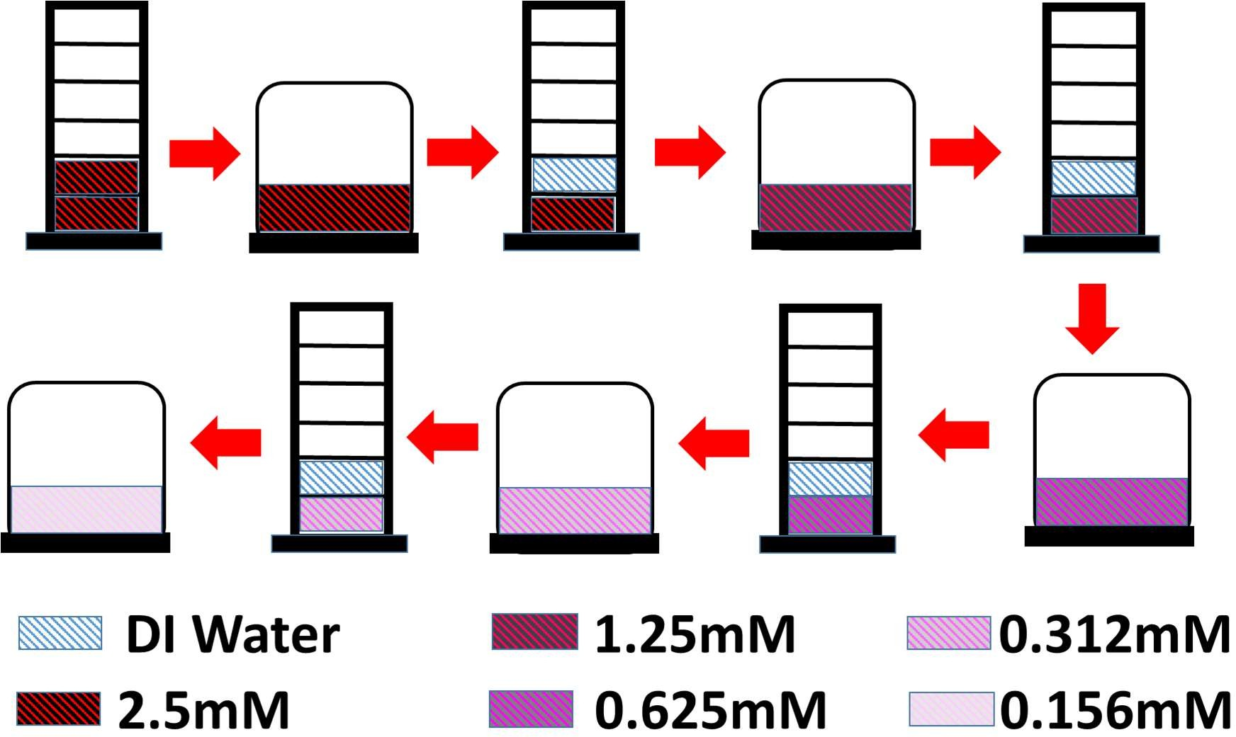

Titrations
Titration is a form of quantitative chemical analysis used to measure the unknown concentration, of a constituent of a sample, known as an analyte. It is achieved by adding to the measured sample an exactly known quantity of another substance with which the desired constituent reacts in a definite, known proportion. The process is usually carried out by gradually adding a standard solution (i.e. a solution of known concentration) of titrating reagent, or titrant, from a burette, essentially a long, graduated measuring tube with a stopcock and a delivery tip at its lower end. At the equivalence point of a titration, an exactly equivalent amount of titrant has been added to the sample. The experimental point at which the completion of the reaction is marked by some signal is called the end point. This signal can be the colour change of an indicator or a change in some chosen, e.g., electrical property, that is measured during the titration. The difference between the end point and the equivalence point is the titration error, which is kept as small as possible by the proper choice of an end- point signal and a method for detecting it.
For many titration reactions it is possible to find a suitable visual colour indicator that will signal the end point at, or very close to, the equivalence point. Such titrations, classified according to the nature of the chemical reaction occurring between the sample and titrant, include: acid-base titrations, precipitation titrations, complex- formation titrations, and oxidation-reduction (redox) titrations.
In an acid-base titration (i.e. the titration of an acid with a base, or vice versa), the indicator is a substance that can exist in two forms, an acid form and a basic form, which differ in colour. For example, litmus is blue in alkaline solution and red in acid solution. Phenolphthalein is colourless in acid solution and pink in alkaline solution. A wide choice of acid-base indicators is available, varying not only in the colours of the two forms but also in the pH value at which the colour occurs.
The endpoint of precipitation titrations is marked by the appearance of a coloured precipitate. One way in which this can be done is by employing potassium chromate
- as the indicator. Another method involves the use of an adsorption indicator, the indicator action being based on the formation on the surface of the precipitate of an adsorbed layer of an indicator salt, which forms only when an excess of precipitant ions is present.
The most important titrations based upon complex-formation reactions are those involving the titration of metal ions with the reagent disodium ethylenediaminetetraacetate (a salt of edetic acid, or EDTA). The indicators are dyes that have the property of forming a coloured complex with the metal ion. As the titration proceeds, the reagent reacts first with uncomplexed metal ions, and, finally, at the end point it reacts with the metal-indicator complex. The colour change corresponds to the conversion of the metal-dye complex into the free dye.

In oxidation-reduction (redox) titrations the indicator action is analogous to the other types of visual colour titrations. Close to the end point, the indicator undergoes oxidation or reduction, depending upon whether the titrant is an oxidizing agent or a reducing agent. The oxidized and reduced forms of the indicator have distinctly different colours.
Alternatively, for many titrations the end point can be detected by electrical measurements. These titrations may be classified according to the electrical quantity that is measured. Potentiometric titrations involve the measurement of the potential difference between two electrodes of a suitable cell; conductometric titrations , the electrical conductance or resistance of the solution being titrated; and amperometric titrations , the electric current passing during the course of the titration. In the titrations just mentioned the end point is indicated by a marked change in the electrical quantity that is being measured.

EXPERIMENT 1: SOLUBILITY AND METAL-LIGAND COMPLEXING

- OBJECTIVES
After completing this practical and the associated exercises you should be able to:
- conduct a precipitation titration
- manipulate logarithms algebraically
- determine the formula of a metal-ligand complex from suitable titrimetric data
- understand the principles of metal-ligand equilibria in solution and how such equilibria affect mineral solubility

- INTRODUCTION

  - Solubility and metal-ligand complexing

The solubility of many minerals in water may be enhanced considerably by the formation of metal-ligand complexes. For example, the solubility of galena (PbS) is greater in salty waters than fresh waters because of lead-chloride complex formation:

PbS (galena) + H⁺ (aq) ⇋ Pb²⁺ (aq) + HS⁻ (aq)
Pb²⁺ (aq) + 4C1⁻ (aq) ⇋ PbC1₄²⁻(aq)

Our ability to model mineral solubility behaviour during water-rock reactions involving saline waters therefore depends on our knowledge of the nature and stability of metal-ligand complexes formed.
In this experiment, we aim to determine the formula of the predominant silver-ammine complex in ammonia-rich solutions.

  - Silver-ammine complexing
If a silver nitrate solution is titrated with potassium bromide, the former providing silver ions and the latter bromide ions, then at the precipitation end-point i.e. when silver bromide just starts to precipitate, the following equilibrium applies:

AgBr (s) ⇋ Ag⁺ (aq) +Br⁻ (aq)
With K_{sp} = [Ag⁺(aq)] × [Br ⁻(aq)]

Where K_{sp} is the solubility product of silver bromide, and [ ] refers to the concentration of the enclosed species.

If the silver nitrate solution also contains large amounts of ammonia, then the following equilibrium may be established:

Ag⁺ (aq) + nNH₃ (aq)⇋Ag(NH₃)_{n}⁺ (aq)
With
K_{n} = [Ag(NH₃)_{n}⁺ (aq)] / ([NH₃(aq) ]^{n}×[Ag⁺ (aq)])

where Kn is the formation constant of the given silver ammine complex, and [ ] refers to the moles of the enclosed species.

moles of KBr = (moles of NH₃)^{n} × K_{n} × K_{sp}/ moles of AgNO₃

Taking logarithms of both sides gives:

log(moles of KBr)= n log(moles of NH3) + log (K_{n} × K_{sp}/ moles of AgNO₃)

Thus a plot of log (moles-KBr) against log(moles-NH₃) for a series of solutions in which moles of AgNO₃ was constant would be expected to result in a series of points forming a straight line with slope equal to n, the number of ammine molecules present in each molecule of the predominant silver-ammine complex.

Thus if we titrate silver nitrate-ammonia solutions of various different ammonia amounts against a potassium bromide solution, then we may be able to determine the formula of the predominant silver ammine complex, Ag(NH₃)_{n}⁺(aq),using the equation above.
If we ensure that the total volume of the solution is the same at the end-point of each titration, then it follows that the volume of ammonia solution added and the volume of potassium bromide solution added will be proportional to the concentrations NH₃ and KBr respectively and that concentrations of AgNO₃ will remain constant.
Thus, n may be determined by plotting log (moles of KBr solution) against log (moles of NH₃ solution).

- PRE-LABORATORY PREPARATION

  - Read the whole procedure for this experiment.
  - Make a note of any step or steps in the procedure that you do not understand and ask your demonstrator for clarification prior to commencing the practical.
  - Make a list of equipment and reagents that you will require so that you can check the availability of these at the beginning of the practical.
  - Make a note of any steps involving potential hazards and consider a strategy to avoid. During the practical, ask your laboratory supervisor before commencing such steps if in any doubt.

- PROCEDURE

  - You will have on your bench a clearly labelled plastic bottle containing approximately 60 ml of 0.01M silver nitrate solution. Pour this into the small beaker and use the syringe to take a 20ml aliquot and place into the 250ml beaker.
  - Take a 40ml aliquot of 2M ammonia and add to the 20ml of silver solution in the 250ml beaker. The ammonia can be obtained from a large beaker in the fume cupboard.
  - Dilute the silver nitrate/ammonia mix with de-ionised water to a total volume of 100 ml.
  - Titrate the mixture in the beaker with the 0.02M KBr solution from the 50 ml burette until the first permanent turbidity appears. You may find it useful to view the beaker against a dark background. Record the volume of KBr solution used as well as the total volume of the mixture. Rinse out the beaker with deionised water. You may find it useful to conduct a rough trial titration to determine the approximate volume of titrant required and how the solution changes colour over the end-point.
  - Repeat steps 4.1 to 4.4 however this time using only 10 ml of the 2M NH₃ solution. Be sure to add a sufficient volume of deionised water to bring the TOTAL volume of the solution near to that recorded initially in step 4.4.
  - Dispose of the beaker contents into one of the collection beakers in the fume cupboard. DO NOT dispose of the SILVER BROMIDE down the sink.
DATASHEET EXPERIMENT
NAME:
DATE:
CLASS: EART26201.
- Titration of silver nitrate-ammonia with potassium bromide
VOLUME (ml)  0.01M AgNO₃ | VOLUME (ml)  2M NH₃ | VOLUME (ml)  0.02M KBr | TOTAL VOLUME  (in ml)
(20) | (40)
(20) | (30) | 10.6 | 115.6
(20) | (15) | 2.5 | 113.5
(20) | (10)
( ) indicates nominal volume of solution to be added

- Plot the log of moles KBr on y axis against log of moles NH3 on x axis. Determine the straight line of best fit, either by eye or by hand/computer calculation.

- Write down the equation of the best fit line.

- Write down the determined value of n and therefore the formula of the predominant silver ammine complex.

- If the titrations were continued past the precipitation end-point and the volume of potassium bromide solution added recorded and used in the calculations for n, which equation outlined in section 2 would become invalid and why?

- The solubility product of silver bromide at 20°C is 5 × 10⁻¹³ according to Fritz and Schenk (1979). Use this value to estimate the formation constant, K_{n}, for the predominant silver amine complex found in this experiment. (Hint: Use the data from just ONE titration or just ONE point on your best-fit line).

EXPERIMENT 2 BUFFERS AND INDICATORS

PERFORMANCE OBJECTIVES
After completing this practical and the associated exercises you should be able to:

  - understand the concept of a pH buffer and the term "buffer capacity"
  - calibrate a specific simple pH meter
  - understand the principle of pH indicators
  - carry out an acid/base titration
  - accurately use a volumetric flask

INTRODUCTION

BUFFERS AND MINERALS
If the compositions of groundwaters and hydrothermal fluids were completely randomly variable then we should have an impossible task to understand their chemistry. Fortunately, time and time again analyses of groundwaters and hydrothermal fluids show that their compositions often fall into quite narrow ranges.
For example, many groundwaters have silica concentrations close to that expected if they were in equilibrium with quartz. Typically, the host rocks for such groundwaters contain excess free quartz which controls the dissolved silica concentration: should the silica concentration decrease then more quartz will dissolve to tend to return the concentration to its equilibrium value:
SiO2 (quartz) + 2H2O (aq) ⇋ H2SiO4 (aq)

should the silica concentration increase then quartz may precipitate tending again to return the concentration to its equilibrium value:
H4SiO4 (aq) ⇋ SiO2 (quartz) + 2H2O (aq)

If these mechanisms are effective in maintaining a relatively constant level of dissolved silica then the quartz is said to BUFFER the solution (against change).
Other compositional parameters may also be buffered by minerals or mineral assemblages. For example, in many granite-hosted hydrothermal systems, the ratio (K+/H+) is buffered by the assemblage quartz + K-feldspar + muscovite according to the equilibrium:
3KAlSi3O8(K-feldspar) + 2H⁺ (aq) ⇋ KAl3Si3O10(OH)2 (muscovite) + 2K⁺(aq) + 6SiO2(quartz)

The quartz + K-feldspar + muscovite assemblage may act as a buffer only whilst all of the individual minerals in the assemblage coexist.

BUFFER SOLUTIONS
Composition parameters such as pH may also be buffered by the coexistence of substantial quantities of two appropriate dissolved species within the aqueous phase.
A good example of a buffer solution is a concentrated solution of weak acid and its salt, for example a 0.1M acetic acid (CH3COOH)/ 0.1M sodium acetate (CH3COONa) solution.

pH of a weak acid/salt buffer solution

The dissociation of acetic acid is governed by the dissociation constant, K., which is the equilibrium constant for:
HA ⇋ H+ + A-

Where A = CH3COO⁻

and Ka = [H⁺][A⁻]/[HA]

Thus [H⁺] = Ka × [HA]/[A⁻] Eq. A

If [ACID] is the analytical concentration of acetic acid

then [HA] = [ACID] – [H+] Eq. B

Sodium acetate is a strong electrolyte that is essentially completely dissociated so that, if [SALT] is the analytical concentration of sodium acetate

then | [Na+] = [SALT]
and | [A-] = [Na+] + [H+] | (from charge balance)
Thus | [A-] = [SALT] + [H+] | Eq. C

Substituting the derived expressions for [HA] and [A-] into Eq. A results in: [H⁺] = Ka × ([ACID] - [H⁺])/([SALT] + [H⁺])

For a sufficiently concentrated solution (e.g 0.1M), the hydrogen ion concentration (assumed to be approximately equivalent to activity here) is negligible compared to [ACID] and [SALT] provided that the acid is a weak acid. Thus:
[ACID] - [H+] = [ACID]

and

[SALT] + [H+] = [SALT]

so that [H⁺] = Ka × [ACID]/[SALT]
or pH = pKa + log([SALT]/[ACID])

For acetic acid Ka = 1.82 x 10⁻⁵ mol/L
Thus pKa = -log (Ka/(mol/l)) = 4.74

Thus, the pH of a 0.1M acetic acid/0.1M sodium acetate solution is 4.74.

Buffering capacity of a weak acid/salt buffer solution

What happens if 10 ml of 0.1M HCl is added to 1 litre of the 0.1M acetic acid/0.1M sodium acetate solution?

The HCl in the 0.1M HCl solution is almost completely dissociated. The hydrogen ions from the HCl disrupt the equilibrium between the acetate ions and acetic acid, reacting with acetate ion to form more acetic acid:
H⁺ + CH3COO⁻ = CH3COOH
Thus the concentrations of acetate ion and acetic acid become:

[A-] = 0.1 - 0.001 = 0.09 = [SALT]
[HA] = 0.1 + 0.001 = 0.11 = [ACID] thus pH = 4.74 + log([SALT]/[ACID])
= 4.74 + log (0.09/0.11)

= 4.74 - 0.09

= 4.65

PRE-LABORATORY PREPARATION

- 3.1 Read the whole procedure for this experiment.
- 3.2 Read the handout entitled “Alkalinity”
- 3.3 Make a note of any step or steps in the procedure that you do not understand and ask your demonstrator for clarification prior to commencing the practical.
- 3.4 Make a list of equipment and reagents that you will require so that you can check the availability of these at the beginning of the practical.
- 3.5 Make a note of any steps involving potential hazards and consider a strategy to avoid. During the practical, ask your laboratory supervisor before commencing such steps if in any doubt.

THE INDICATORS

Phenolphthalein

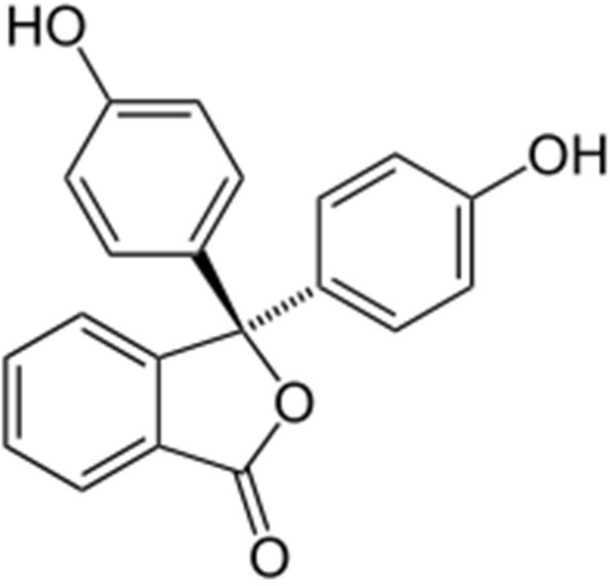

pH 0-8.3 8.3-10 >10

colour Colourless Pink to Fuchsia Colourless

Conditions Acidic-near neutral /slightly
basic
basic Strongly basic

Screened methyl orange
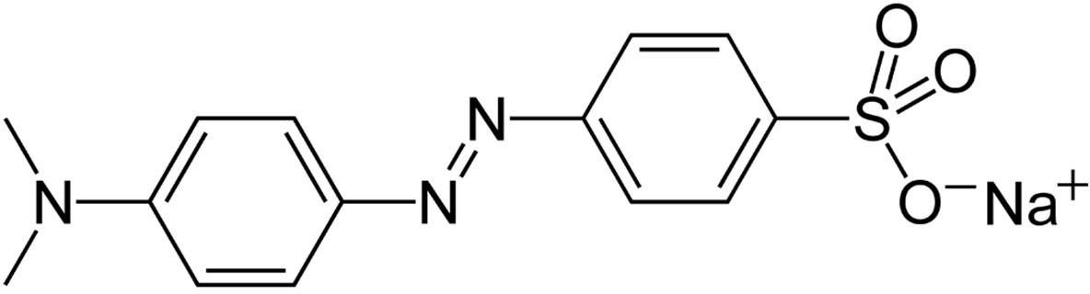

pH | Below pH 3.1 | Above pH 4.4 to pH10+
colour | Red | Yellow
Conditions | Strongly acidic | From mildly acidic to strongly basic

PROCEDURE

Calibration of pH Meter
Check that the pH meter reads 7.0 ± 0.2 when immersed in the pH 7 buffer solution provided. (Remember to take the cap off!).

If the pH meter reads outside the range 6.8 - 7.2 then use the small screwdriver to adjust the appropriate screw (labelled on the back of the meter) to give the correct calibrated reading.
Carefully rinse the bottom of the pH meter in tap water and then deionised water. Ensure that you have dry hands when handling the pH meter and that you immerse only the bottom part of the meter in the solution. Keep pH meter vertical at all times.
AFTER ensuring that the pH meter is in calibration for a pH 7 buffer now check the calibration with the pH 4 buffer provided in the same manner. The pH meter should read 4.0 ± 0.2 for this solution. If the pH meter reads outside the range 3.8 - 4.2 then use the small screw driver to adjust the calibration by turning the correct screw on the side of the meter.
Carefully rinse the bottom of the pH meter in tap water and then deionised water.

As a final check, put the pH meter back in the pH 7 buffer solution and check the pH reader. If the pH reading is outside the range 6.8 -7.2 then repeat the calibration procedure.
The pH meter should now be ready and calibrated for use.

Buffer capacity of solutions

Add FOUR DROPS of screened methyl orange indicator solution to two of the following solutions (one buffer and one water) and then titrate with 0.1M HCl using the burette. Add 5 ml in total of 0.1M HCl to each solution in increments of approximately 0.5 ml. Note
- the pH and burette reading after each increment;

- how long the pH reading takes to stabilise (this might vary from a few seconds to several tens of seconds); and
- any colour changes in the solution. Remember to thoroughly rinse the beakers with deionised water before studying each new solution.
  - 100 ml pH = 7 buffer solution

OR

  - 100 ml pH = 4 buffer solution

AND

  - 100 ml deionised water

OR

  - 100 ml tap water

Titration of a strong base with a strong acid
- You will find a plastic bottle on your bench containing approx.: 100 ml of 0.01M sodium hydroxide stock solution in a clearly labelled bottle.
- Use the volumetric flask to measure out exactly 100 ml of this solution into a 250 ml beaker.
- Measure the pH of the solution in the beaker.
- Add TWO DROPS of phenolphthalein solution and note the change, if any, to the pH of the solution.
- Using the 50 ml burette, titrate the 0.01M NaOH solution in the 250 ml beaker with the 0.1M HCl solution. The titrant (0.1M HCl) should be added in increments as described below, with the volume of titrant added and the pH measured and recorded after each increment. After every addition, leave enough time for the pH to stabilise before adding the next increment.
Add the 0.1M HCl in approximately 0.5 ml increments until the pH falls below 10.7 and then add in 0.1 ml increments until the pink colour of the phenolphthalein disappears. Make a note of colour change and immediately after the solution turns colourless, add FOUR DROPS of screened methyl orange indicator and continue the titration, adding 0.1 ml of titrant at a time. Note and record the total volume added and the pH as well as any changes in the colour of the solution. Stop the titration when the pH falls below 3.
- Plot pH vs volume of 0.1M HCl added.

Calculate the buffer capacity for all the solutions whose pH was measured during the titration. Plot buffer capacity vs pH.
- Cleaning up

Thoroughly but carefully wash the pH probe with deionised and tap water. Place a small amount of tap water in the protective cap and place on the end of the probe prior to storage. Remember to switch it OFF. Remember to clean any glassware you have used and to tidy and clean your bench space.

DATA SHEET EXPERIMENT 2. Date: Time:
- Calibration of pH Checker Number of pH Checker:
Measured pH of pH 7 buffer solution □ reading from meter ………………………..

Measured pH of pH 4 buffer solution □ reading from meter ………………………..

- Buffer capacity measurements

Choose which buffer you want to analyse and tick the corresponding box

(i) pH = 7 □or (ii) pH = 4 □buffer solution

BURETTE READING  (ml) | VOLUME 0.1M  HCl  ADDED (ml) | pH | COLOUR/COMMENTS

DATA SHEET EXPERIMENT 2. Date: Time:

Choose which water you want to analyse and tick the corresponding box

(iii) Deionised □or (iv) tap water □

BURETTE READING  (ml) | VOLUME 0.1M  HCl  ADDED (ml) | pH | COLOUR/COMMENTS

DATA SHEET EXPERIMENT 2. Date: Time:

3.a Plot pH vs volume (ml) of 0.1M HCl added for either,

(i) pH 7 buffer solution □; (ii) pH 4 buffer solution □



DATA SHEET EXPERIMENT 2. Date: Time:
3b. Plot pH vs volume (ml) of 0.1M HCl added for either,

(iii) deionised water□ or and (iv) tap water



DATA SHEET EXPERIMENT 2. Date: Time:
5. Titration of 0.01M NaOH with 0.1M HCl.

BURETTE READING  (ml) | VOLUME 0.1M  HCl  ADDED (ml) | pH

DATA SHEET EXPERIMENT 2. Date: Time:
- Titration of 0.01M NaOH with 0.1M HCl continued.

BURETTE READING  (ml) | VOLUME 0.1M  HCl  ADDED (ml) | pH


DATA SHEET EXPERIMENT 2. Date: Time:
6. Plot pH vs volume of 0.1M HCl added for titration of 0.01M NaOH solution. 7.

POST-LABORATORY QUESTIONS

  - Which is a better buffer solution: tap water or deionised water ?

  - What is the significance of the end-point in the titration of the 0.01 M NaOH solution with 0.1 M HCl? Explain how such a titration could be used to determine the concentration of an unknown NaOH solution.

  - Over what pH ranges do the indicators below appear to change colour ?
    - methyl orange
    - phenolphthalein

  - The indicator bromo-thymol blue changes colour from yellow in acid solutions to blue in alkaline solutions over the pH range 6.0-7.6. Why might the transition pH range for bromo-thymol blue be more suitable for determining the NaOH titration with HCl end-point ?

  - How good a pH buffer would a mixture of 100 ml of 0.1M NaOH and 100m1 of 0.1M HCl solution be? Explain your answer.

  - Small samples of (i) a groundwater with a low buffer capacity; and (ii) a groundwater with a high buffer capacity; are collected and returned to the lab where the pH values of these samples was measured. Which sample's pH value is likely to be more representative of the pH of the groundwater from which it was taken ? Explain your answer.

